**PRACTICAL FILE**

**NAME** – DHANANJAY YADAV

**COURSE -** BCA (AIML)

**GROUP** - 1

**Q1**. Create a simple html page using basic tags.

**Ans.** <HTML>

<HEAD>

<TITLE>INTRODUCTION</TITLE>

</HEAD>

<BODY>

<H2> HTML FILE </H2>

</BODY>

</HTML>

**OUTPUT –**

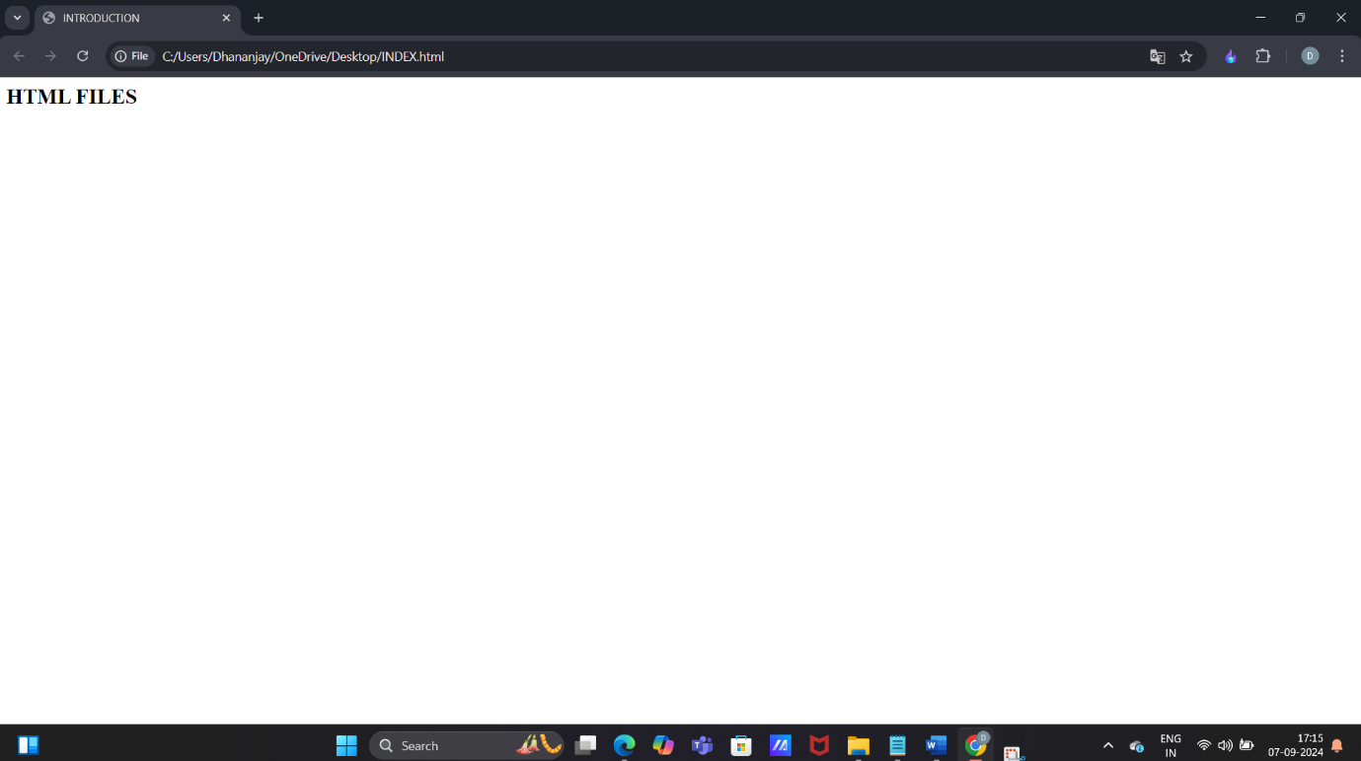

**Q2.** Create a web page that displays your name to the screen.

**Ans. <HTML>**

**<HEAD>**

**<TITLE>INTRODUCTION</TITLE>**

**</HEAD>**

**<BODY>**

**<H1> DHANANJAY YADAV </H1>**

**</BODY>**

**</HTML>**

**OUTPUT –**

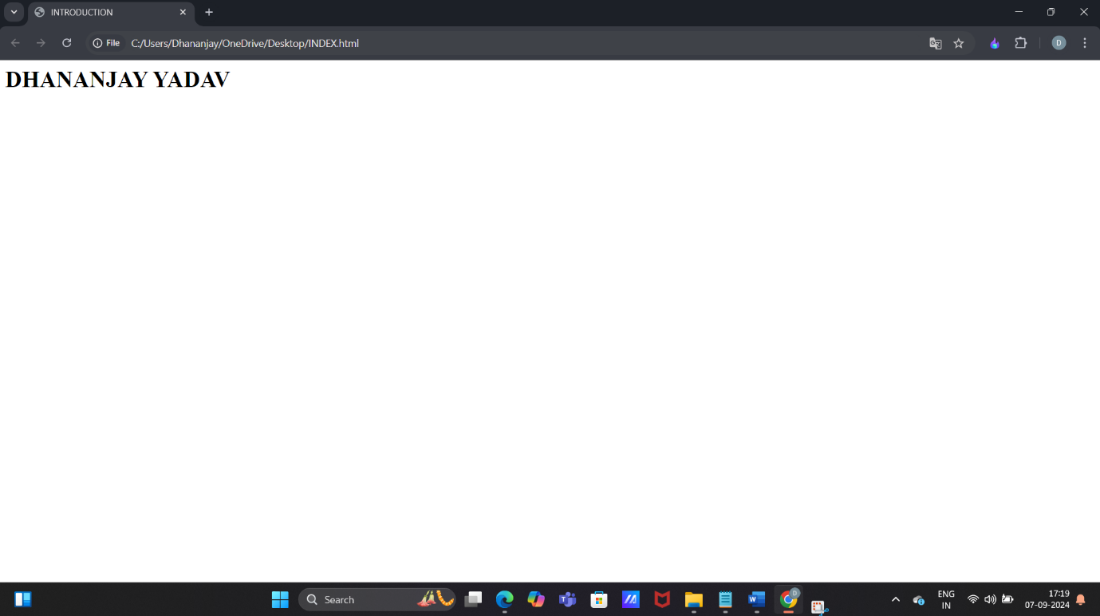

**Q3.** Create a web page and show the output from 1 to 10 in separate lines.

**Ans. <HTML>**

**<HEAD>**

**<TITLE>INTRODUCTION</TITLE>**

**</HEAD>**

**<BODY>**

**1<br>2<br>3<br>4<br>5<br>6<br>7<br>8<br>9<br>10<br>**

**</BODY>**

**</HTML>**

**OUTPUT –**

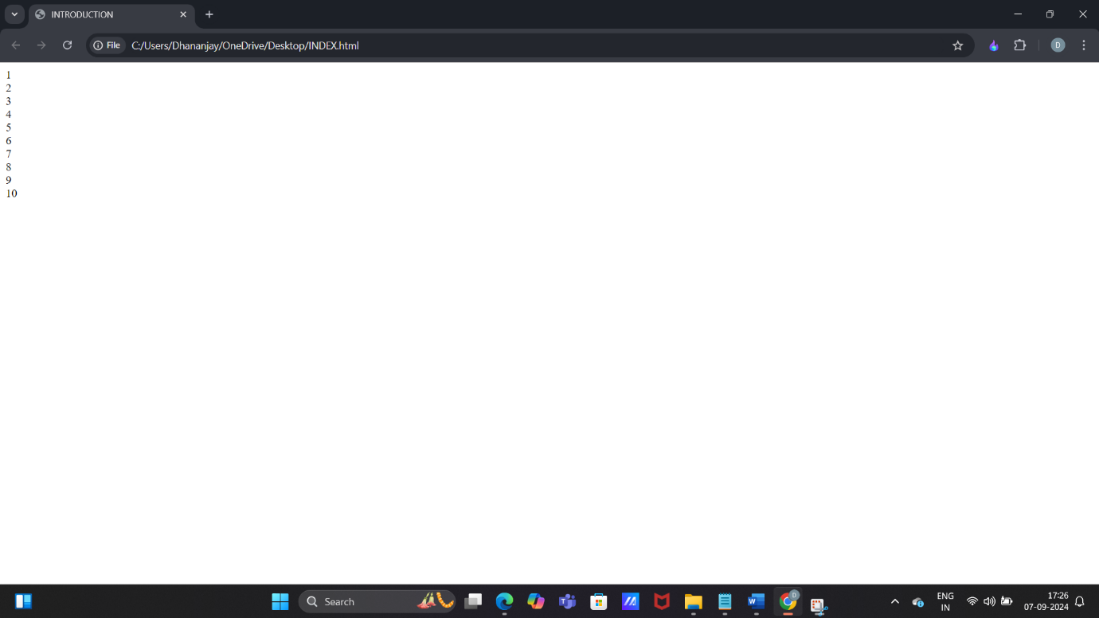

**Q4.** Create a web page and show the output from 1 to 10 in separate lines, each number being in different colour.

**Ans. <HTML>**

**<HEAD>**

**<TITLE>INTRODUCTION</TITLE>**

**</HEAD>**

**<BODY>**

**<font color="blue">1</font><br>**

**<font color="green">2</font><br>**

**<font color="yellow">3</font><br>**

**<font color="red">4</font><br>**

**<font color="brown">5</font><br>**

**<font color="black">6</font><br>**

**<font color="orange">7</font><br>**

**<font color="purple">8</font><br>**

**<font color="grey">9</font><br>**

**<font color="pink">10</font><br>**

**</BODY>**

**</HTML>**

**Output –**

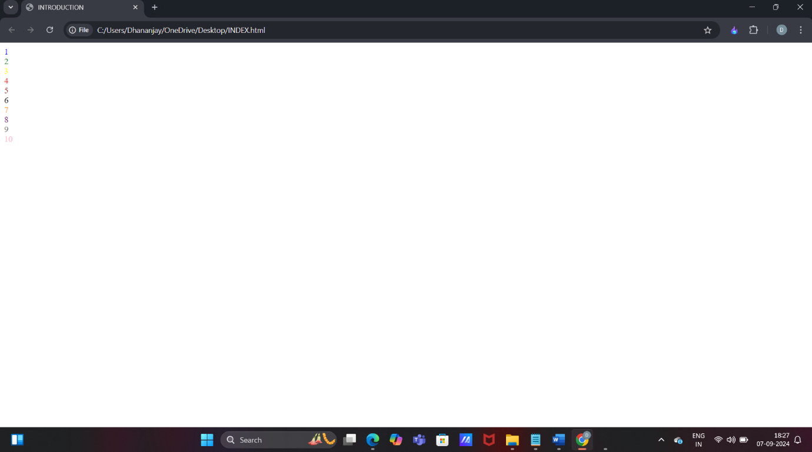

**Q5. How do I make a picture as a background on my web pages?**

**Ans. <HTML>**

**<HEAD>**

**<TITLE>INTRODUCTION</TITLE>**

**</HEAD>**

**<BODY background="C:\Users\Dhananjay\OneDrive\Pictures/download.jpg">**

**</BODY>**

**</HTML>**

**OUTPUT –**

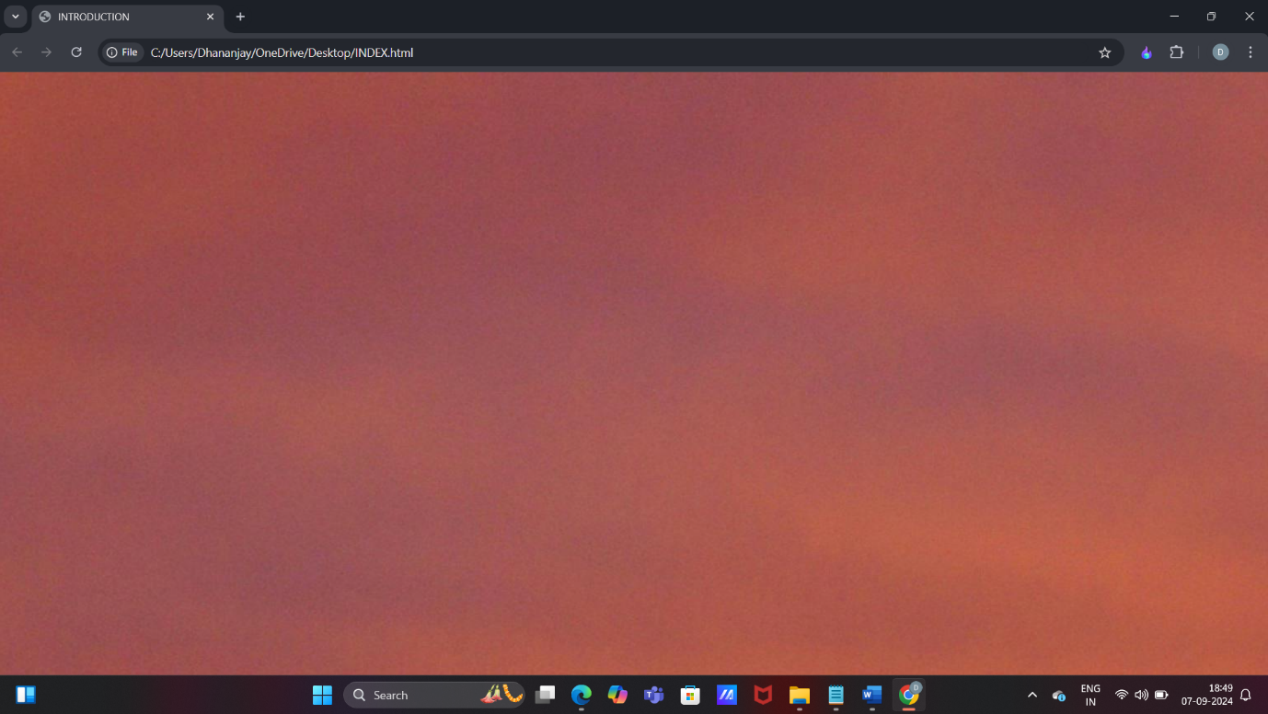

**Q6**. Create a web page to print paragraph with 4-5 snetences, each sentence shall have a different colour.

**Ans. <HTML>**

**<HEAD>**

**<TITLE>INTRODUCTION</TITLE>**

**</HEAD>**

**<BODY>**

**<P>**

**<H1><CENTER> HTML </CENTER> </H1><BR>**

**<H2 STYLE="FONT-FAMILY:VERDANA;">Hyper Text Markup Language(HTML) is a markup language used to create web pages.</H2>**

**<H3 STYLE="FONT-FAMILY:COURIER;">HTML is often used with Cascading Style Sheets(CSS) and JavaScript.</h3>**

**<h4 STYLE="FONT-FAMILY:MONOSPACE;">CSS is used to change the way HTML looks.</h4>**

**<h3 STYLE="FONT-FAMILY:BRUSH SCRIPT;">JavaScript tells websites how to behave.</h3>**

**</P>**

**</BODY>**

**</HTML>**

**OUTPUT –**

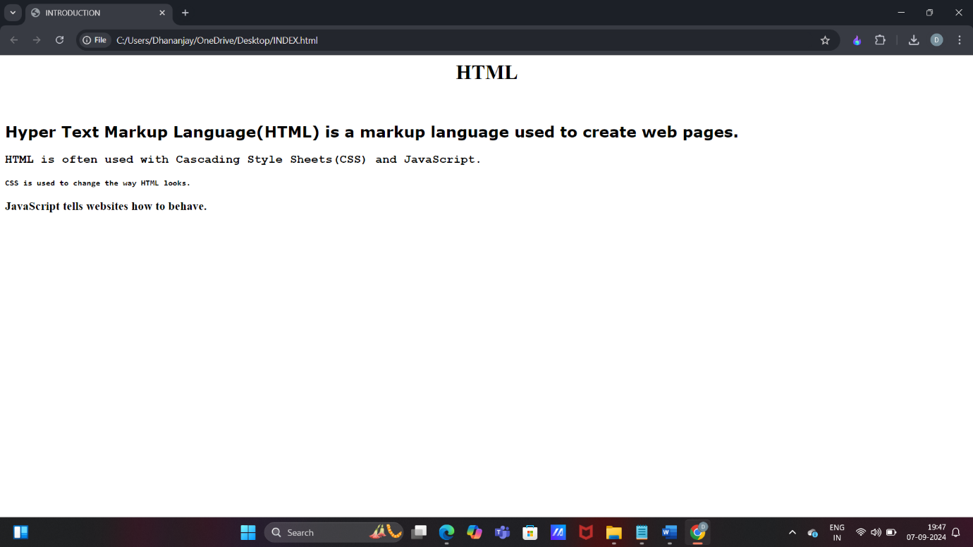

**Q7.** Write HTML code to print a paragraph that is descriptions of a book, it shall include the title of book, its author name; name and title should be underlined and all adjactives shall be bold and italics.

**Ans. <HTML>**

**<HEAD>**

**<TITLE>INTRODUCTION</TITLE>**

**</HEAD>**

**<BODY bgcolor="dark orange">**

**<h1 style="color:gold;"><u><b><center> LORD OF THE RINGS </center></b></u></h1>**

**<h2 style="color:gold;"><u><b><center> J.R.R. TOLKIEN </center></b></u></h2>**

**<h3><b>GENRE</b></h3>**

**<b><i>Epic</i></b> highly <b><i>fantasy</i></b> novel.**

**<h3><b>READ IF</b></h3>**

**You love <b><i>fantasy</i></b> world and have a <b><i>passion</i></b> for heavy writing, deep explanations.**

**<h3><b>FUN FACT </b></h3>**

**Tolkien is said to have typed all 1200 pages of The Lord of rings with two fingers.**

**<br>**

**<p>**

**The Lord of rings is highly <i><b>fantasy</i></b> novel, written between 1937-1949. All three parts of the masterpiece are steeped in magic and otherworldliness. The epic story centres around <b>Frodo Baggins</b>, who is force to leave his hometown of the Shire to make a<b><i> perilous</i></b> journey across the realm of Middl-earth to destroy a powerful ring, deep inside the territories of the Dark Lord Sauron.**

**</p>**

**</BODY>**

**</HTML>**

**OUTPUT –**

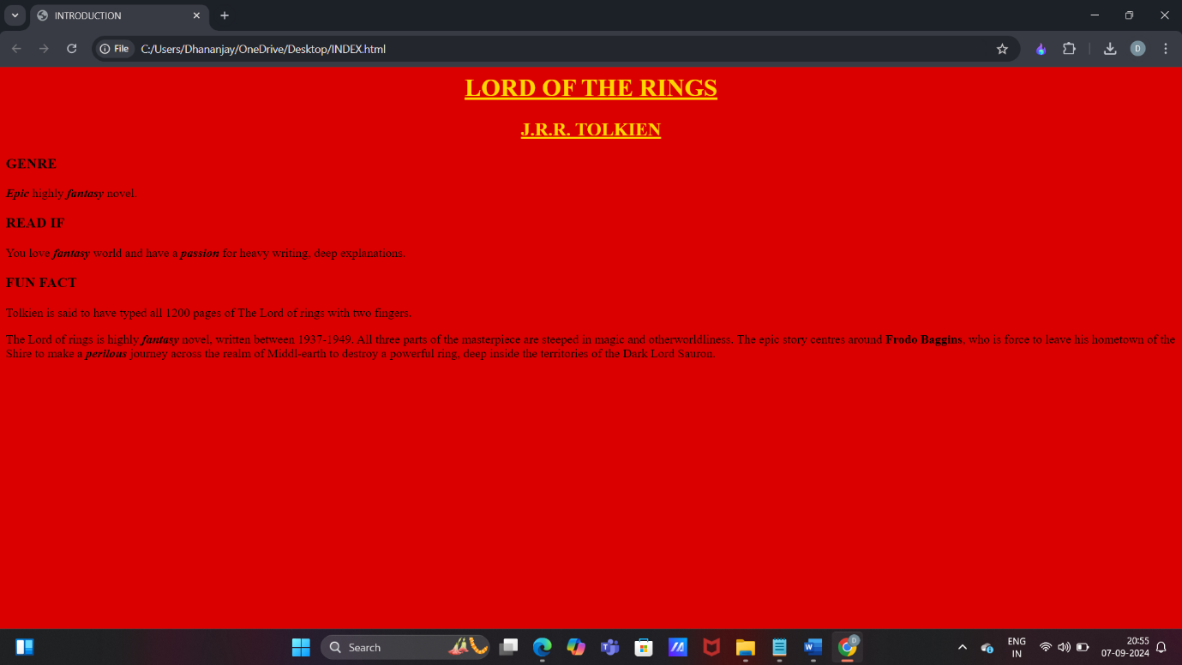

**Q8.**  Write HTML code to print your name using heading tags, every letter shall be of different heading size.

**Ans. <HTML>**

**<HEAD>**

**<TITLE>INTRODUCTION</TITLE>**

**</HEAD>**

**<BODY>**

**<h1>D</h1>**

**<h2>H</h2>**

**<h3>A</h3>**

**<h4>N</h4>**

**<h5>A</h5>**

**<h4>N</h4>**

**<h3>J</h3>**

**<h2>A</h2>**

**<h1>Y</h1>**

**</BODY>**

**</HTML>**

**OUTPUT –**

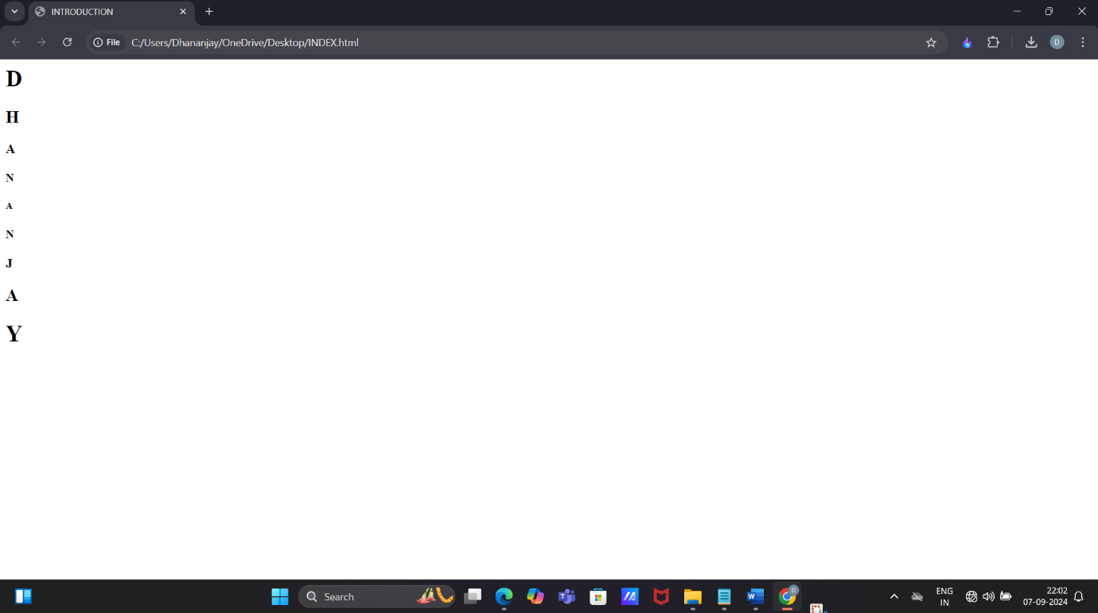

**Q9.** Write HTML code to print the sequence of number 1-20. Each number shall be in different line with number 2 next to it as subscript, an equal sign and result.

**ANS.** **<HTML>**

**<HEAD>**

**<TITLE>INTRODUCTION</TITLE>**

**</HEAD>**

**<BODY>**

**<p>1<sub>2</sub> = 1</p>**

**<p>2<sub>2</sub> = 4</p>**

**<p>3<sub>2</sub> = 9</p>**

**<p>4<sub>2</sub> = 16</p>**

**<p>5<sub>2</sub> = 25</p>**

**<p>6<sub>2</sub> = 36</p>**

**<p>7<sub>2</sub> = 49</p>**

**<p>8<sub>2</sub> = 64</p>**

**<p>9<sub>2</sub> = 81</p>**

**<p>10<sub>2</sub> = 100</p>**

**<p>11<sub>2</sub> = 121</p>**

**<p>12<sub>2</sub> = 144</p>**

**<p>13<sub>2</sub> = 169</p>**

**<p>14<sub>2</sub> = 196</p>**

**<p>15<sub>2</sub> = 224</p>**

**<p>16<sub>2</sub> = 256</p>**

**<p>17<sub>2</sub> = 289</p>**

**<p>18<sub>2</sub> =324 </p>**

**<p>19<sub>2</sub> = 361</p>**

**<p>20<sub>2</sub> = 400</p>**

**</BODY>**

**</HTML>**

**OUTPUT –**

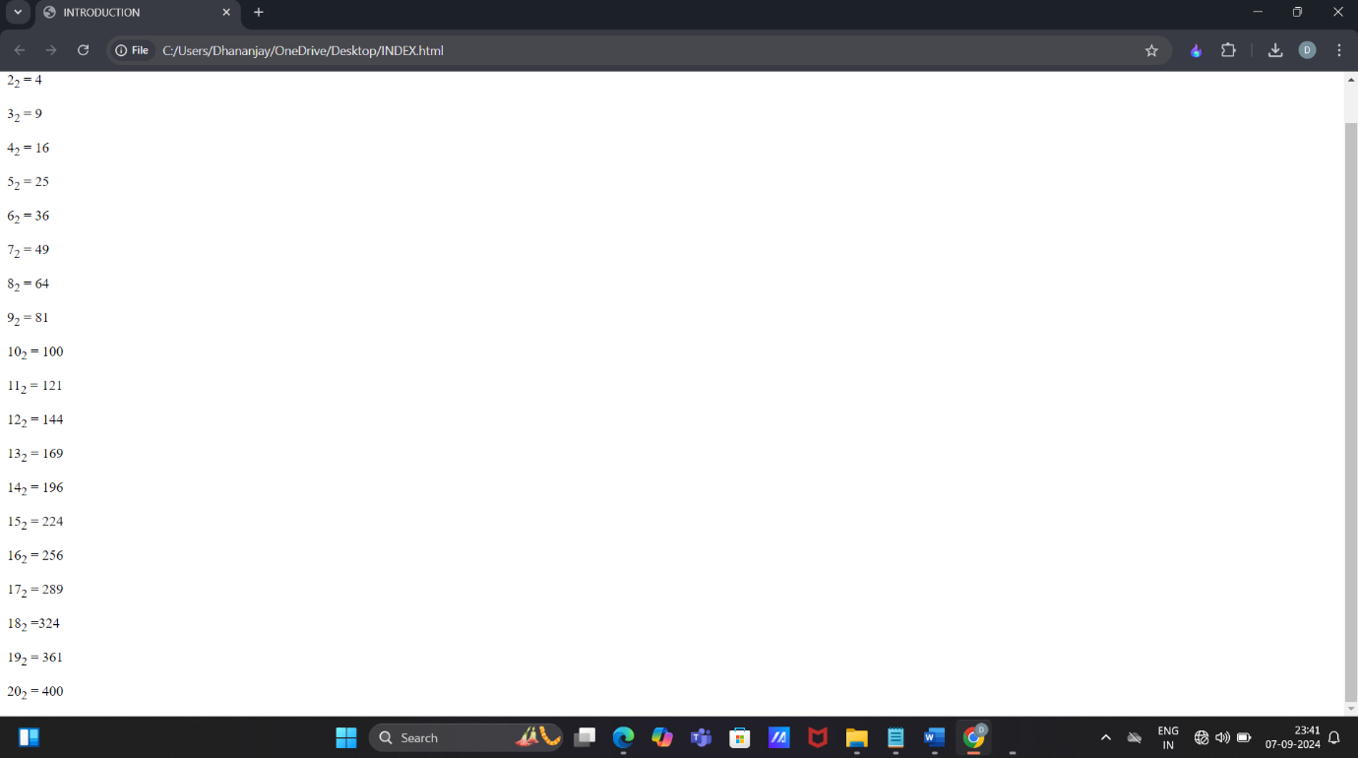

**Q10.** Write HTML code to display an image with border of size with width 200, height 200 pixel, leaving H space and V space of your choice with image hanging in the right side on the screen.

**Ans. <HTML>**

**<HEAD>**

**<TITLE>INTRODUCTION</TITLE>**

**<style>**

**img{**

**border:2px solid black;**

**width:200px;**

**height:200px;**

**display:block;**

**margin-left:auto;**

**margin-right:0;**

**margin-top:50px;**

**margin-bottom:40px;**

**</style>**

**</HEAD>**

**<BODY>**

**<img src="C:\Users\Dhananjay\Pictures\Screenshots/display.jpg"**

**alt="sample image">**

**</BODY>**

**</HTML>**

**OUTPUT –**

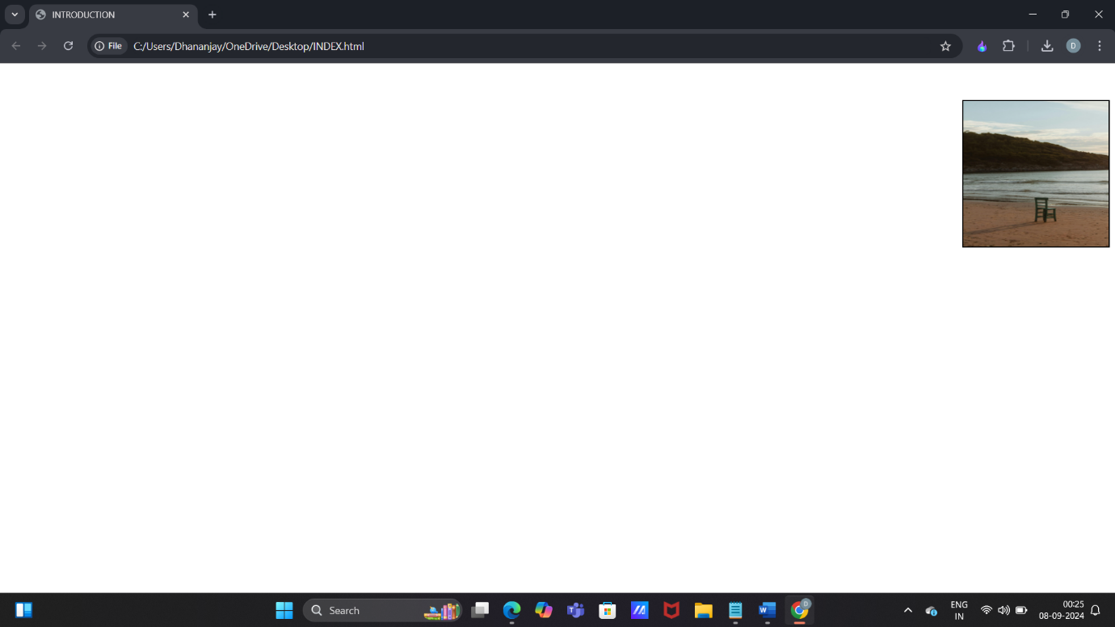

**Q11.** Write HTML code to create a web page with heading. The heading shall be displayed at the top-center of the page and the image shall be at the center, just below the heading.

**Ans. <HTML>**

**<HEAD>**

**<TITLE>INTRODUCTION</TITLE>**

**<style>**

**body{**

**margin:0;**

**font-family:arial, sans-serif;**

**text-align:center;**

**justify-content:center;**

**align-items:center;**

**</style>**

**</head>**

**<body>**

**<h1>GANESH CHATURTHI 2024</h1>**

**<img src="C:\Users\Dhananjay\OneDrive\Pictures/modak.jpg"**

**alt="FESTIVAL CELEBRATION">**

**</BODY>**

**</HTML>**

**OUTPUT –**

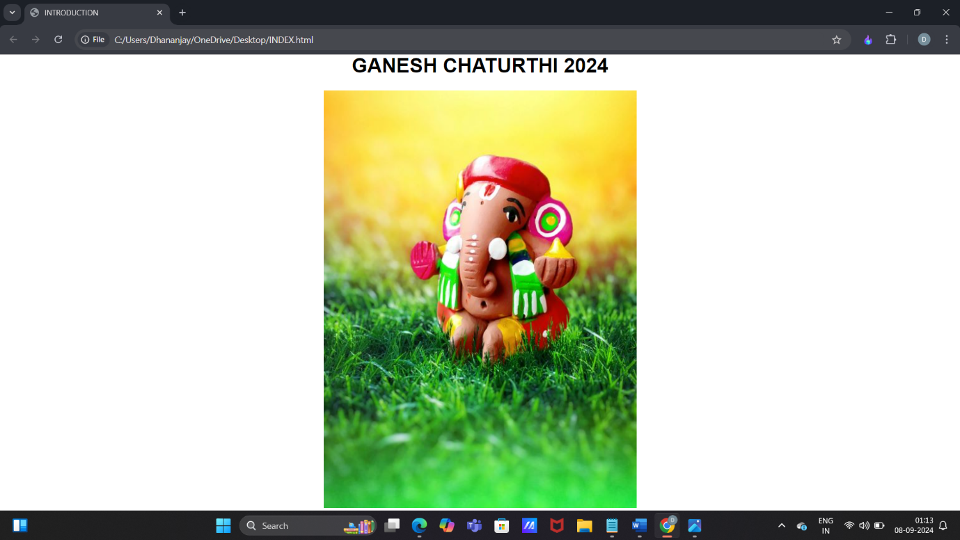

**Q12.** Write HTML code using Multimedia tags.

**Ans. <HTML>**

**<HEAD>**

**<TITLE>MULTIMEDIA TAGS</TITLE>**

**</head>**

**<body>**

**<h1 align="center">MULTIMEDIA</H1>**

**<hr>**

**<video src="C:\Users\Dhananjay\OneDrive\Pictures/jungle.mp4" controls="controls" width="720" height="480">**

**</video>**

**<br>**

**<audio src="C:\Users\Dhananjay\OneDrive\Pictures/nightforest.mp3" controls="controls" autoplay="autoplay">**

**<embed src="name.pdf" width="px" height="px">**

**<object data="file.name" width="px" height="px">**

**</object>**

**</BODY>**

**</HTML>**

**OUTPUT –**

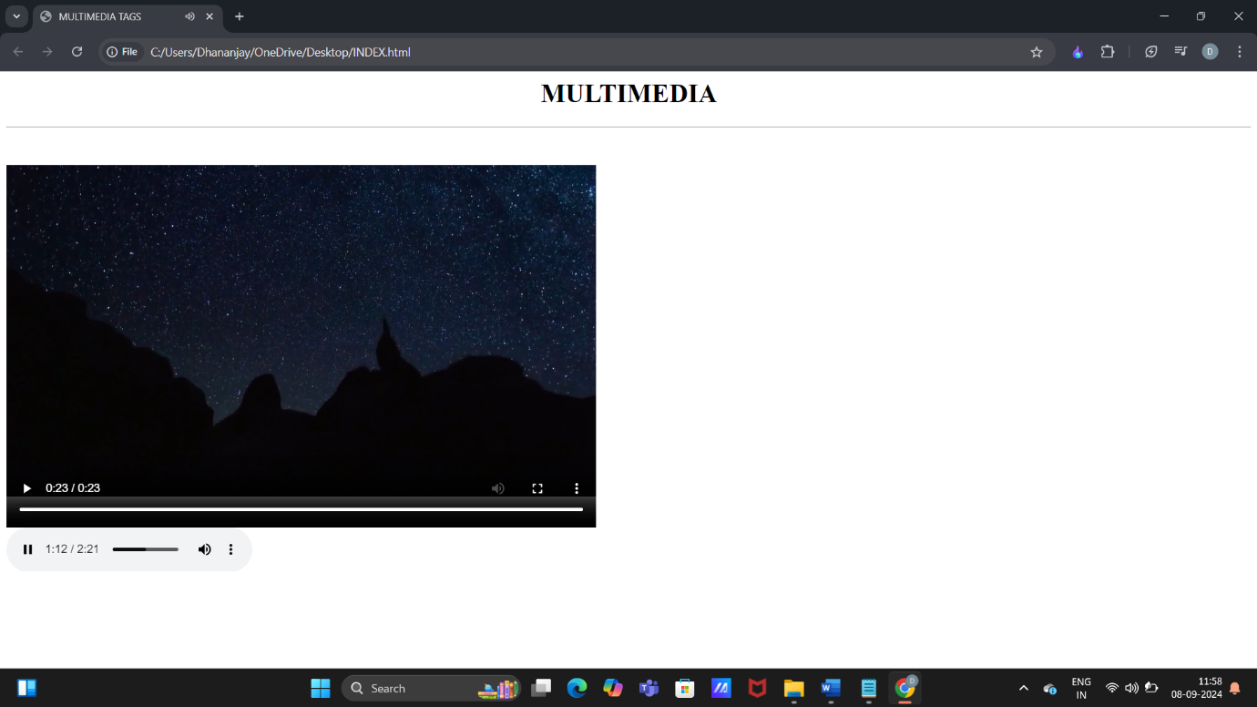

**Q13.** Create a Table using Rowspan and Colspan taking example of student record.

**Ans. <html>**

**<head>**

**<title>table</title>**

**</head>**

**<body>**

**<table border="2">**

**<tr>**

**<td rowspan="2">ATTENNDENCE</td>**

**<td>70%</td>**

**<td>80%</td>**

**<td></td>**

**<td></td>**

**</tr>**

**<tr>**

**<td>DETAIN</td>**

**<td>AVAIL</td>**

**<td></td>**

**<td></td>**

**</tr>**

**<tr>**

**<th colspan="2"> NAME </th>**

**<th>ROLL NO </th>**

**<th>COURSE</th>**

**<th>LOCATION</th>**

**</tr>**

**<tr>**

**<td>SHIVAM</td>**

**<td>SINGH</td>**

**<td>01</td>**

**<td>MCA</td>**

**<td>DELHI</td>**

**</tr>**

**<tr>**

**<td>MANU</td>**

**<td>PRATAP</td>**

**<td>02</td>**

**<td>BCA</td>**

**<td>RAJASTHAN</td>**

**</tr>**

**<tr>**

**<td rowsplan="2">ROHIT</td>**

**<td>GAUTAM</td>**

**<td>03</td>**

**<td>BBA</td>**

**<td>HARYANA</td>**

**</tr>**

**<tr>**

**<td>KAMLESH</td>**

**<td>PANDEY</td>**

**<td>04</td>**

**<td>B.COM</td>**

**<td>BIHAR</td>**

**</tr>**

**</table>**

**</body>**

**</html>**

**OUTPUT-**

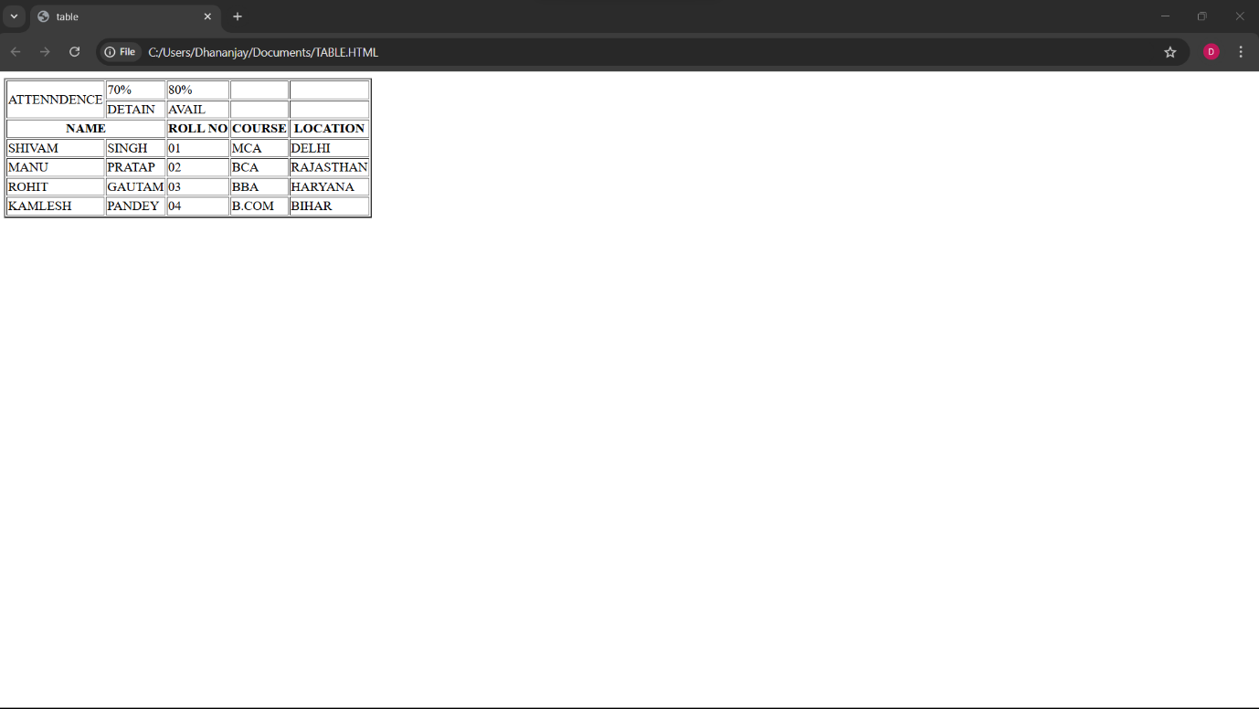

Q14. Write HTML code using table tags <TABLE> and cellpadding and cell spacing as its attributes.

ANS.

<html>

<head></head>

<body>

<table border="2pt" cellspacing="5pt" cellpadding="5pt">

<tr>

<th>S.no</th>

<th>Roll no.</th>

<th>Name</th>

<th>Address</th></tr>

<tr>

<td>1</td>

<td>123</td>

<td>ABC</td>

<td>FBD</td></tr>

<tr>

<td>2</td>

<td>456</td>

<td>XYZ</td>

<td>delhi</td></tr>

<tr>

<td>3</td>

<td>789</td>

<td>PQR</td>

<td>gurgaon</td></tr>

</table></body>

</html>

OUTPUT –

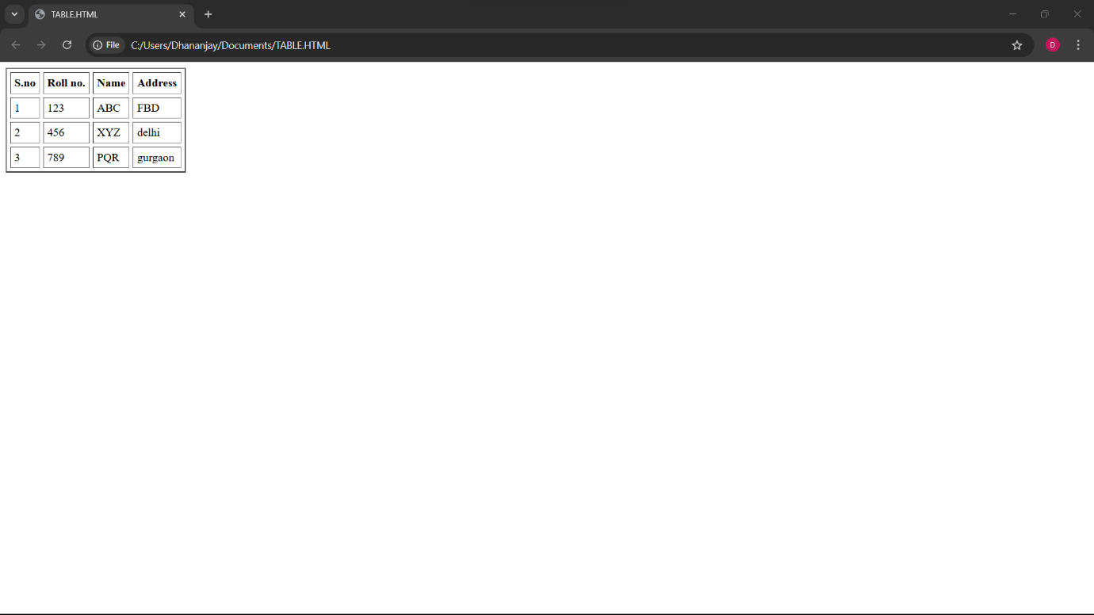

Q15. Create unordered, ordered and definition lists taking example of your subjects in MCA, IST, Iind and IIIrd semester.

ANS.

html>

<head></head>

<body>

<h2> Subjects in BCA sem 1</h3>

<ol>

<li>Web technologies</li>

<li>Introduction to IT & programming in C</li>

<li>Mathematics</li>

<li>DBMS</li>

<li>SDGs</li>

<li>IKS</li>

<li>CDCs</li>

</ol>

<h2> Sunject in BCA sem 2 </h2>

<ul>

<li>COMMUNICATION</li>

<li>DATA STRUCTURE</li>

<li>JAVA</li>

<li>OPERATING SYSTEM</li>

<li>STATICS FOR BCA</li>

</ul>

<h2>Subjects in BCA Sem 3</h2>

<dl>

<dt>C++</dt>

<dt>COMPUTER ARCHITECTURE</dt>

<dt>BUSINESS ECONOMICS</dt>

<dt>ELEMENT OF STATICS</dt>

<dt>DSA OF C++</dt>

</dl>

</body>

</html>

OUTPUT –

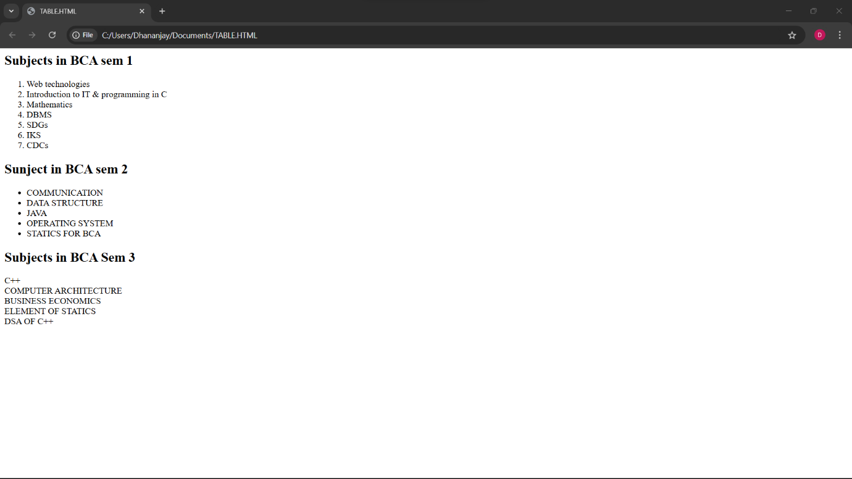

Q16. Write HTML code using <frameset> and <frame> tag with all its attributes.

ANS. <html>

<head>

<title>Frameset Example</title>

</head>

<frameset rows="50%,50%" frameborder="1" bordercolor="black" framespacing="5">

<frame src="https://www.example.com" name="topFrame" scrolling="yes" noresize="noresize" target="_self" />

<frame src="https://www.example.org" name="bottomFrame" scrolling="auto" noresize="noresize" target="_self" />

</frameset>

<noframes>

<body>

<p>Your browser does not support frames. Please update your browser.</p>

</body>

</noframes>

</html>

OUTPUT-

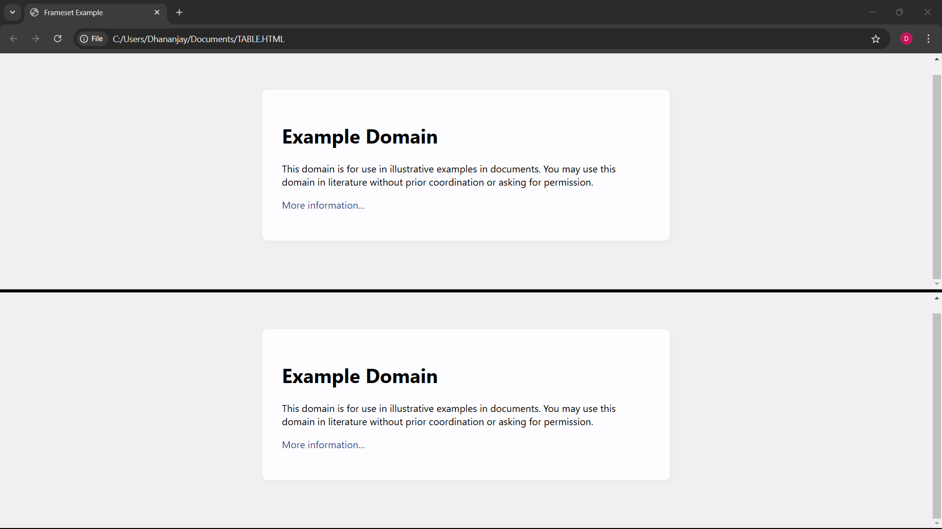

Q17. Write HTML code to design a form in HTML using controls and buttons such as Textbox, Text area,

password, submit button, browse button, drop-down menu.

ANS.

<html>

<head>

<title>Form with Various Controls</title>

</head>

<body>

<h1>Registration Form</h1>

<form action="submit.php" method="post" enctype="multipart/form-data">

<label for="name">Name:</label>

<input type="text" id="name" name="name" required><br><br>

<label for="email">Email:</label>

<input type="email" id="email" name="email" required><br><br>

<label for="password">Password:</label>

<input type="password" id="password" name="password" required><br><br>

<label for="profile_pic">Photograph:</label>

<input type="file" id="profile_pic" name="profile_pic"><br><br>

<label for="country">Country:</label>

<select id="country" name="country">

<option value="india">India</option>

<option value="usa">USA</option>

<option

value="uk">UK</option>

</select><br><br>

<label for="message">Message:</label>

<textarea id="message" name="message" rows="5" cols="30"></textarea><br><br>

<input type="submit" value="Submit">

<input type="reset" value="Reset"><br><br>

</form>

</body>

</html>

OUTPUT –

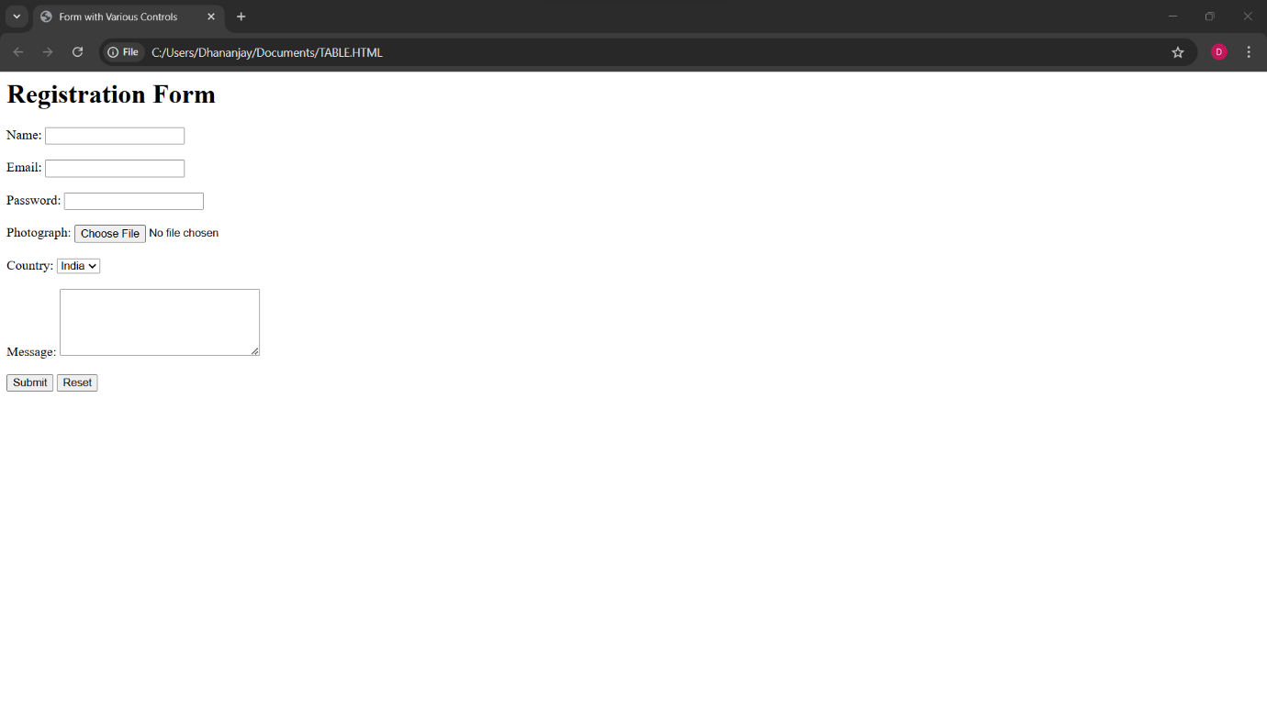

Q18. Write HTML code to design a registration form in html.

ANS.

<html>

<head>

<tiTLE> Registration Form</title>

</head>

<body>

<h1>SPORTS REGISTRATION FORM</h1>

<form action="submit.php" method="post">

<label for="first_name">Participant Name</label><br>

<input type="text" id="first_name" name="first_name" placeholder="First"><br>

<input type="text" name="last_name" placeholder="Last"><br><br>

<lable for="date" name="birth">DOB:</lable>

<input type="date" max="2007" min="2003" required/><br><br>

<label for="gENDER">GENDER</label><br>

<select id="GENDER" name="GENDER">

<option value="">Please select</option>

<option value="MALE">MALE</option>

<option value="FEMALE">FEMALE</option>

</select><br><br>

<label for="school_district">School District</label><br>

<input type="text" id="school_district" name="school_district"><br><br>

<label for="shirt_size">Shirt Size</label><br>

<select id="shirt_size" name="shirt_size">

<option value="">Please select</option>

<option value="s">Small</option>

<option value="m">Medium</option>

<option value="l">Large</option>

<option value="xl">Extra Large</option>

</select><br><br>

<label for="parent_first_name">Parent Name</label><br>

<input type="text" id="parent_first_name" name="parent_first_name" placeholder="First"><br>

<input type="text" name="parent_last_name" placeholder="Last"><br><br>

<label for="emergency_contact">Emergency Contact</label><br>

<input type="text" id="emergency_contact" name="emergency_contact"><br><br>

<input type="submit" value="Submit">

</form>

</body>

</html>

OUTPUT –

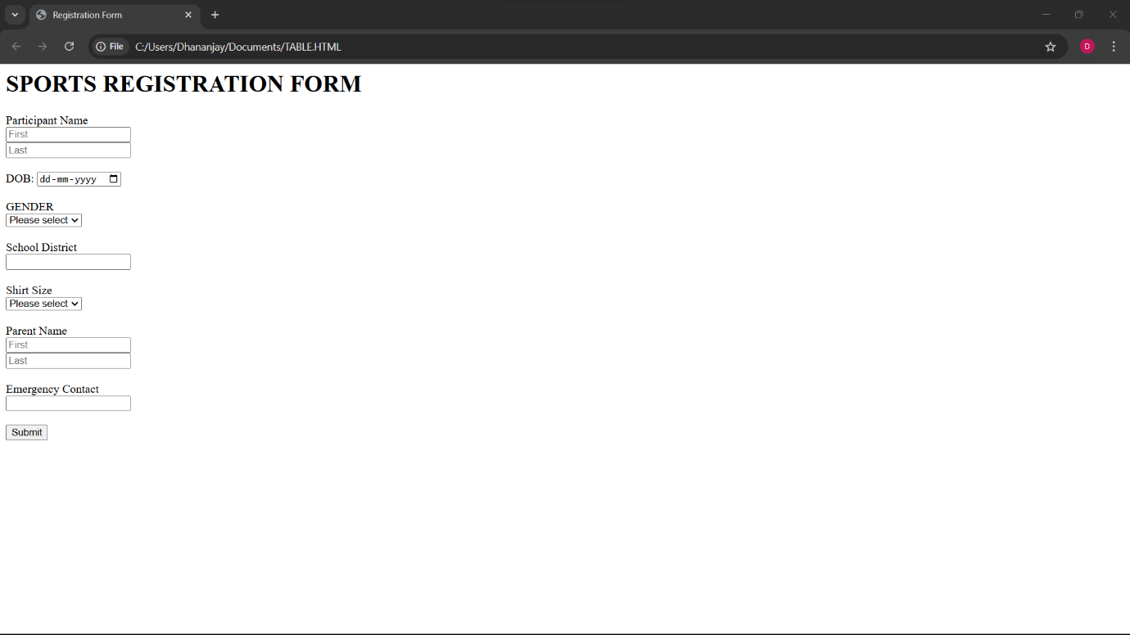

Q19. Write a HTML code to design a student admission form in html.

ANS. <html>

<head>

<title>Student Admission Form</title>

</head>

<body>

<h1>Student Registration Form</h1>

<form action="submit.php" method="post">

<label for="student_name">Student Name</label>

<input type="text" id="student_name" name="student_name" required><br><br>

<label for="date_of_birth">Date of Birth</label>

<input type="date" id="date_of_birth" name="date_of_birth" required><br><br>

<label

for="gender">Gender</label>

<input type="radio" id="male" name="gender" value="male">

<label for="male">Male</label>

<input type="radio" id="female"

name="gender" value="female">

<label for="female">Female</label><br><br>

<label for="address">Address</label><br>

<textarea id="address" name="address"

rows="5" cols="30" required></textarea><br><br>

<label for="phone_number">Phone Number</label>

<input type="tel" id="phone_number" name="phone_number" required><br><br>

<label for="email">Email</label>

<input type="email" id="email" name="email" required><br><br>

<label for="cOURSE">COURSE</label>

<select id="cOURSE" name="cOURSE" required>

<option value="1">BCA</option>

<option value="2">LAW</option>

<option value="3">B.COM</option>

<option value="4">B.TECH</option>

<option value="5">BBA</option>

</select><br><br>

<label for="guardian name">Guardian Name</label>

<input type="text" id="guardian name" name="guardian name" required>

<label for="guardian contact">Guardian Contact</label>

<input type="number" id="guardian contact" name="guardian contact" required><br><br>

<label for="10TH MARKSHEET">10TH Marksheet</label>

<input type="file"><br><br>

<label for="12TH MARKSHEET">12TH Marksheet</label>

<input type="file"><br><br>

<label for="migration_certificate">Migration Certificate</label>

<input type="file"><br><br>

<label for="Character_certificate">Character Certificate</label>

<input type="file"><br><br>

<input type="submit" value="Submit">

</form>

</body>

</html>

OUTPUT –

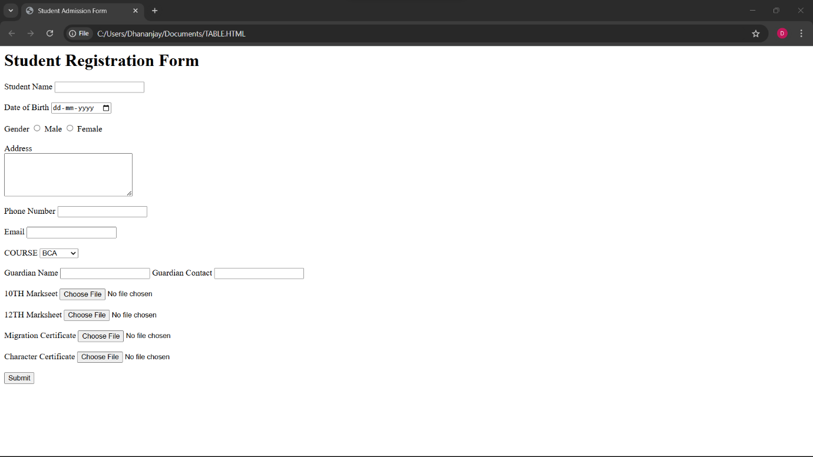

Q20. Create a home page of your own using any component and style.

ANS.

<html>

<head>

<style>

H1, h2, h3 {

text-align: LEFT;

color:orange;

}

#para1 {

text-align: center;

color: Blue;

font-size:20;

}

.center{text-align: center;

color: Green;

font-size:30;

font-family: sans-serif;

}

</style>

</head>

<body bgcolor="yellow">

<H1> CSS</h1>

<h2> Use to style an HTML document </h2>

<p id="para1">CSS save alot of work as it can control the layout of multiple web pages all at once </p>

<p class="center"> External stylesheet are stored in CSS file</p>

<hr>

</body>

</html>

OUTPUT –

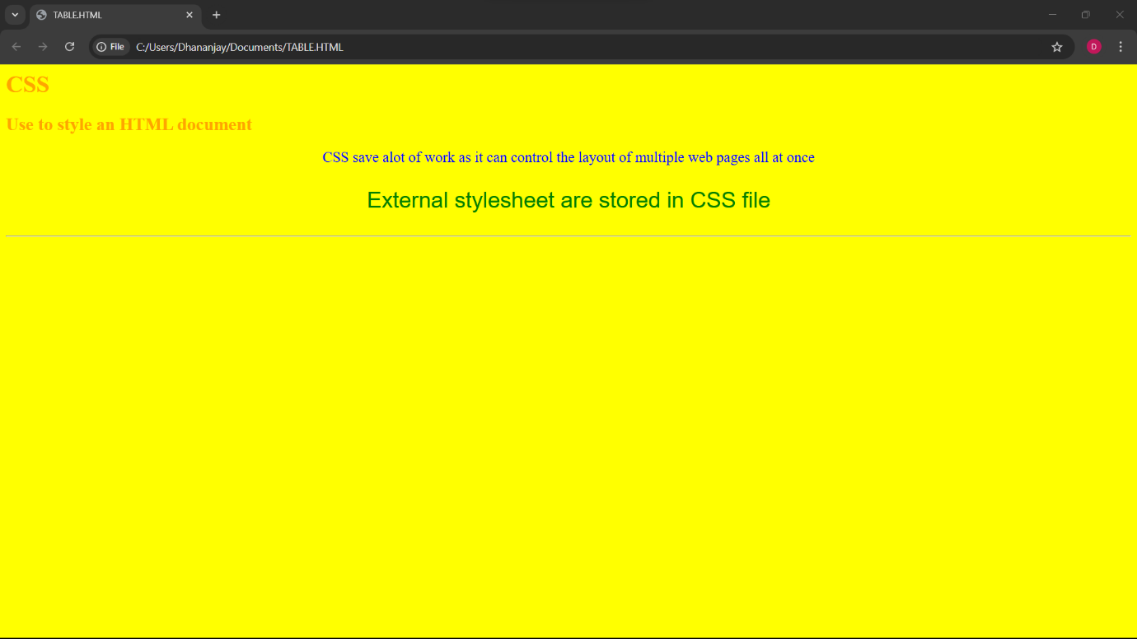

Q21. Write HTML code for including Local hyperlinking in a web page.

ANS. <!DOCTYPE html>

<html>

<head>

<title>Local Links</title>

<style>

body { font-family: Arial, sans-serif; }

section { padding: 20px; margin: 20px 0; background: #f9f9f9; border-radius: 8px; }

a { color: #3498db; text-decoration: none; }

a:hover { text-decoration: underline; }

</style>

</head>

<body>

<nav>

<a href="#home">Home</a> |

<a href="#services">Services</a> |

<a href="#about">About</a> |

<a href="#contact">Contact</a>

</nav>

<section id="home"><h2>Home</h2><p>Welcome to the Home section!</p></section>

<section id="services"><h2>Services</h2><p>Learn about our services.</p></section>

<section id="about"><h2>About</h2><p>Information about our company.</p></section>

<section id="contact"><h2>Contact</h2><p>Get in touch with us.</p></section>

</body>

</html>

OUTPUT –

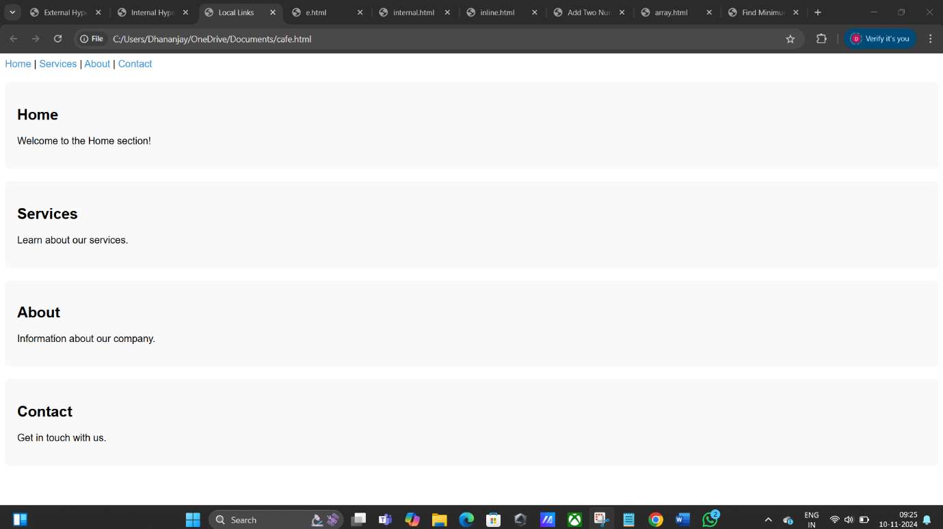

Q22. Write HTML code for including Inter hyperlinking in a web page.

ANS. <!DOCTYPE html>

<html lang="en">

<head>

<title>Internal Hyperlink Example</title>

</head>

<body>

<h1>Welcome to My Webpage</h1>

<p>Click on the links below to jump to different sections of the page:</p>

<!-- Internal Hyperlinks -->

<ul>

<li><a href="#section1">Go to Section 1</a></li>

<li><a href="#section2">Go to Section 2</a></li>

<li><a href="#section3">Go to Section 3</a></li>

</ul>

</body>

</html>

OUTPUT –

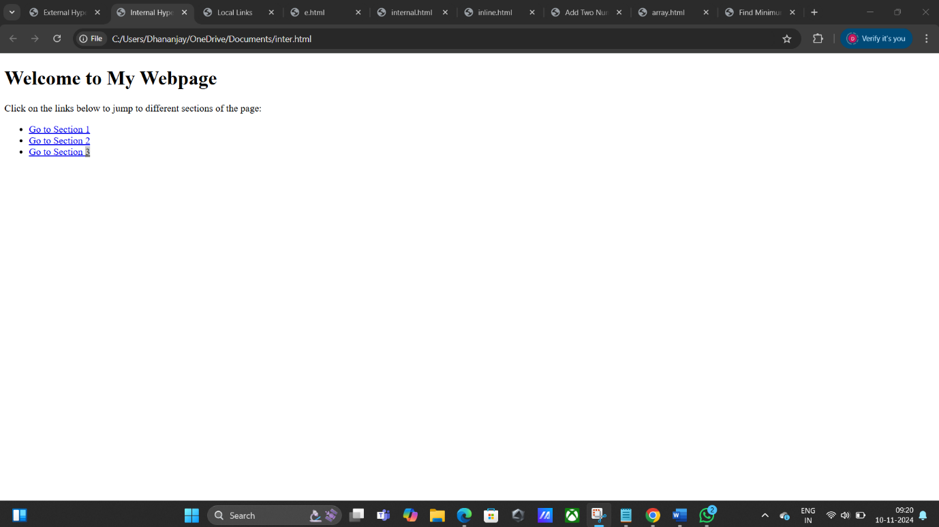

Q23. Write HTML code for including External hyperlinking in a web page.

ANS. <!DOCTYPE html>

<html>

<head>

<title>External Hyperlink </title>

</head>

<body>

<h1>Welcome to My Webpage</h1>

<p>Click this link to visit an external website:</p>

<!-- External Hyperlink -->

<a href="https://www.google.com" target="_blank">Visit External Website</a>

</body>

</html>

OUTPUT –

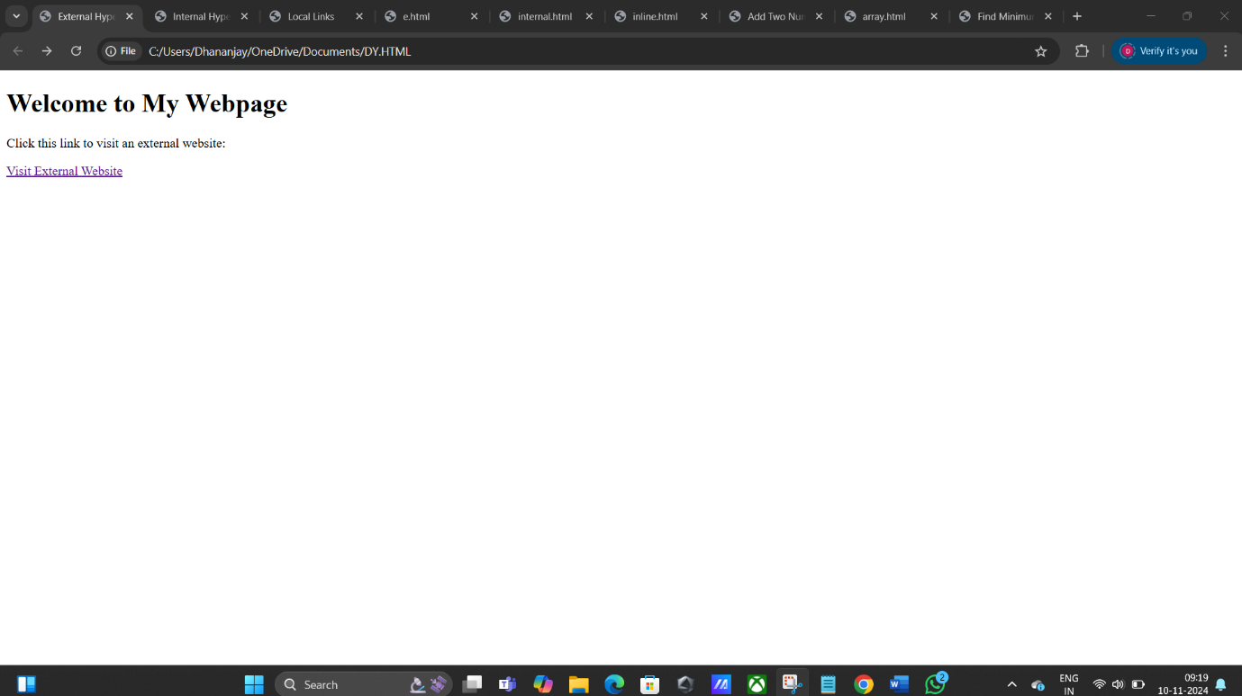

Q24. Write code to show External CSS with HTML code

ANS. <!DOCTYPE html>

<html lang="en">

<head>

<link rel="stylesheet" href="Mystyle.css">

</head>

<body>

<h1>Welcome to My Website</h1>

<p>This is an example of an external CSS file to an HTML document.</p>

</body>

</html>

body {

background-color : yellow ;

}

h1 {

color : navy;

margin-left : 20px;

}

p {

color : red;

margin-center : 30px;

}

OUTPUT –

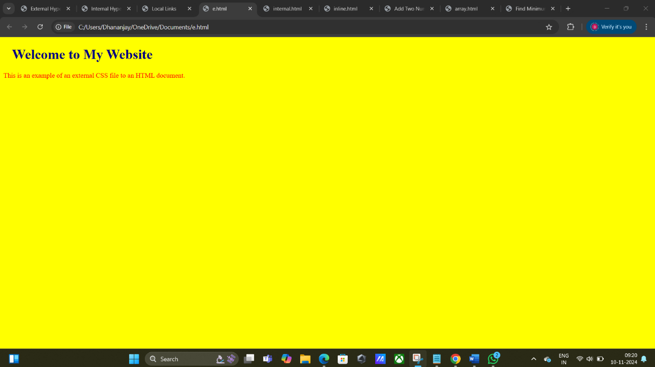

Q25. Write code to show Internal CSS with HTML code.

ANS. <html>

<head>

<style>

body {

background-color : linen;

}

h1 { color : maroon;

margin-center : 40px;

}

p{ color : pink;

margin-left : 30px;

}

</style>

</head>

<body>

<h1> Internal CSS </h1>

<p> This is a Paragraph on internal css. </p>

</body>

</html>

OUTPUT-

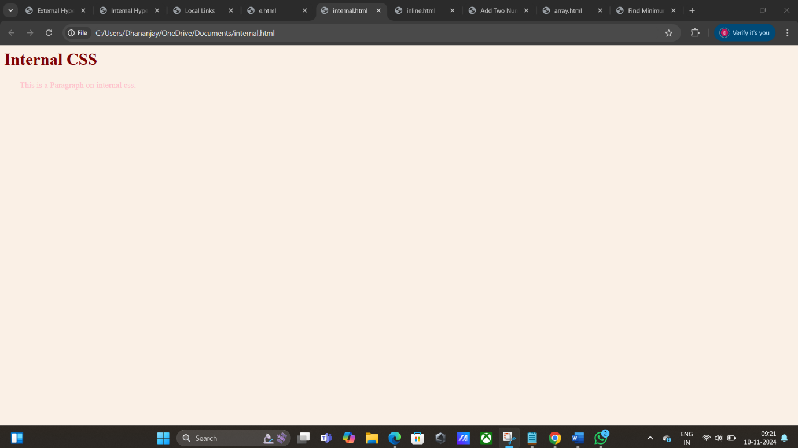

Q26.Write code to show Inline CSS with HTML code.

ANS. <html>

<body>

<h1 style="color :blue; text-align : center; "> Inline CSS </h1>

<p style="color :red; text-align : left;"> This is paragraph on inline css. </p>

</body>

</html>

OUTPUT-

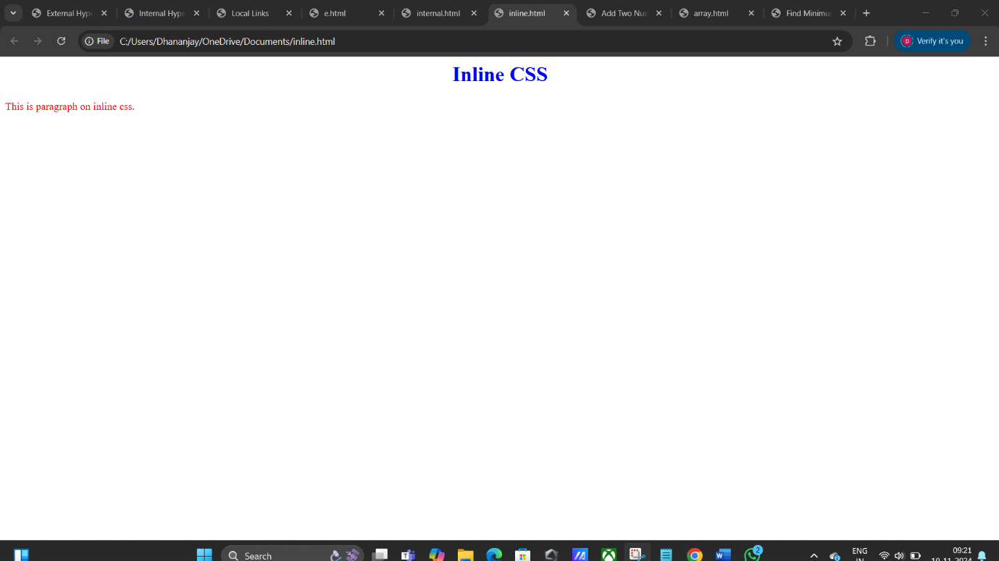

Q27. Write a program to add two numbers using form in JavaScript.

ANS. <html>

<head>

<title>Add Two Numbers</title>

<script>

function addNumbers() {

const num1 = parseFloat(document.getElementById("num1").value);

const num2 = parseFloat(document.getElementById("num2").value);

if (isNaN(num1) || isNaN(num2)) {

document.getElementById("result").innerHTML = "Please enter valid numbers.";

} else {

const sum = num1 + num2;

document.getElementById("result").innerHTML = "Result: " + sum;

}

}

</script>

</head>

<body>

<h2>Addition of Two Numbers using Javascript - </h2>

<form onsubmit="event.preventDefault(); addNumbers();">

<label for="num1">first number: </label>

<input type="number" id="num1" required>

<br><br>

<label for="num2">Second number: </label>

<input type="number" id="num2" required>

<br><br>

<input type="submit" value="Sum">

</form>

<p id="result"></p>

</body>

</html>

OUTPUT –

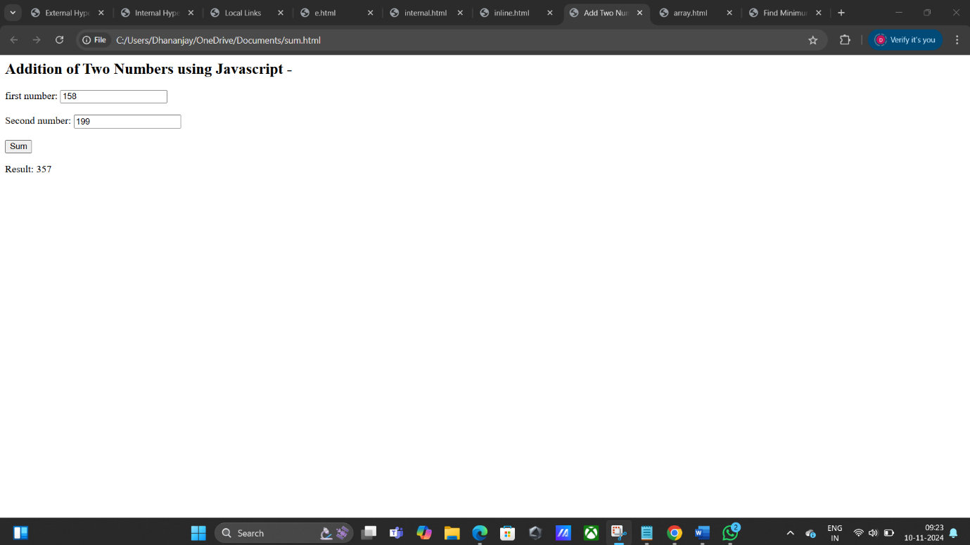

Q29. Write a simple JavaScript program to sort an array

ANS. <!DOCTYPE html>

<html>

<body>

<h1>JavaScript Arrays</h1>

<h2>The sort() Method</h2>

<p>The sort() method sorts the elements of an array.</p>

<p id="demo"></p>

<script>

// Create an Array

const points = [40, 100, 1, 5, 25, 10];

// Sort the Array

points.sort(function(a, b){return a-b});

// Display the Array

document.getElementById("demo").innerHTML = points;

</script>

</body>

</html>

OUTPUT –

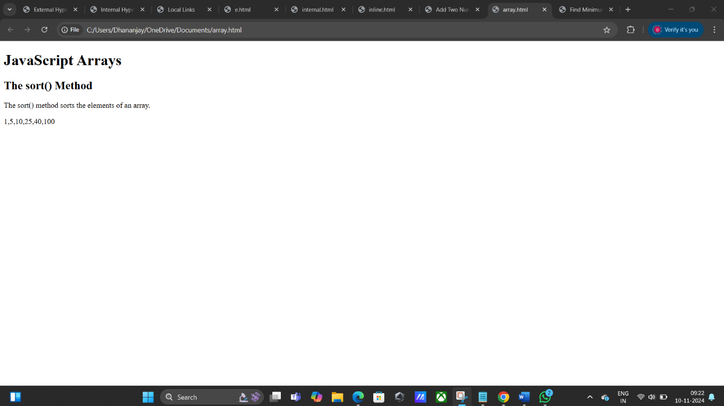

Q30. Write a JavaScript program to take as input three numbers from the user. Find the minimum and maximum of the three numbers. Print the following output in BOLD in the following format:

MINIMUM =        MAXIMUM =

ANS. <html>

<head>

<title>Find Minimum and Maximum</title>

</head>

<body>

<h2>Find Minimum and Maximum of Three Numbers -</h2>

<label for="num1">First number:</label>

<input type="number" id="num1" required>

<br><br>

<label for="num2"> Second number:</label>

<input type="number" id="num2" required>

<br><br>

<label for="num3"> Third number:</label>

<input type="number" id="num3" required>

<br><br>

<button onclick="findMinMax()">Find Minimum and Maximum</button>

<h3 id="output"></h3>

<script>

function findMinMax() {

const num1 = parseFloat(document.getElementById("num1").value);

const num2 = parseFloat(document.getElementById("num2").value);

const num3 = parseFloat(document.getElementById("num3").value);

if (isNaN(num1) || isNaN(num2) || isNaN(num3)) {

alert("Please enter valid numbers in all fields.");

return;

}

const minimum = Math.min(num1, num2, num3);

const maximum = Math.max(num1, num2, num3);

document.getElementById("output").innerHTML = `

<strong>MINIMUM = ${minimum}</strong> &nbsp;&nbsp;&nbsp;&nbsp;

<strong>MAXIMUM = ${maximum}</strong>

`;

}

</script>

</body>

</html>

OUTPUT- 